# Quick Start Guide

#### For librarian System Users

Upon starting the application, the user will see the first page as a **Login** screen.

***Login:***

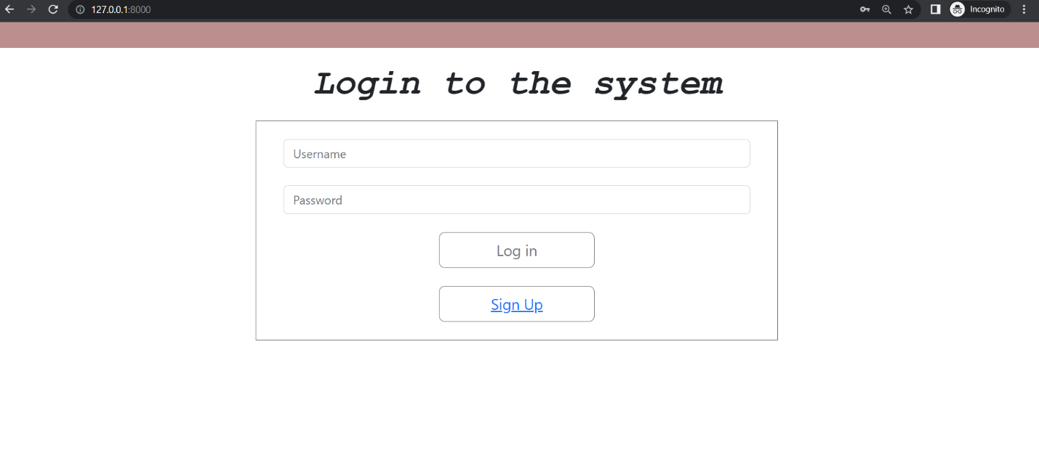

On the login screen the user will asked to enter their credentials to access the library management system. They will be logged-in into the system if the credentials are correct or an error message will be shown to enter the correct credentials.

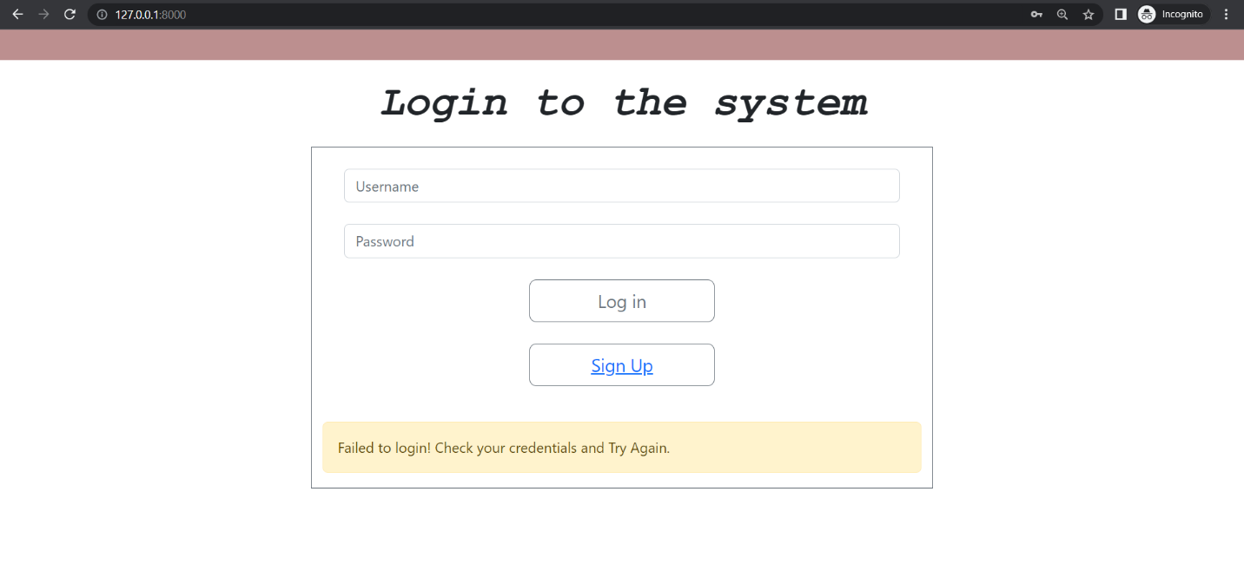

The user won’t be able to access the system unless they login with the correct username and password.

***Sign Up:***

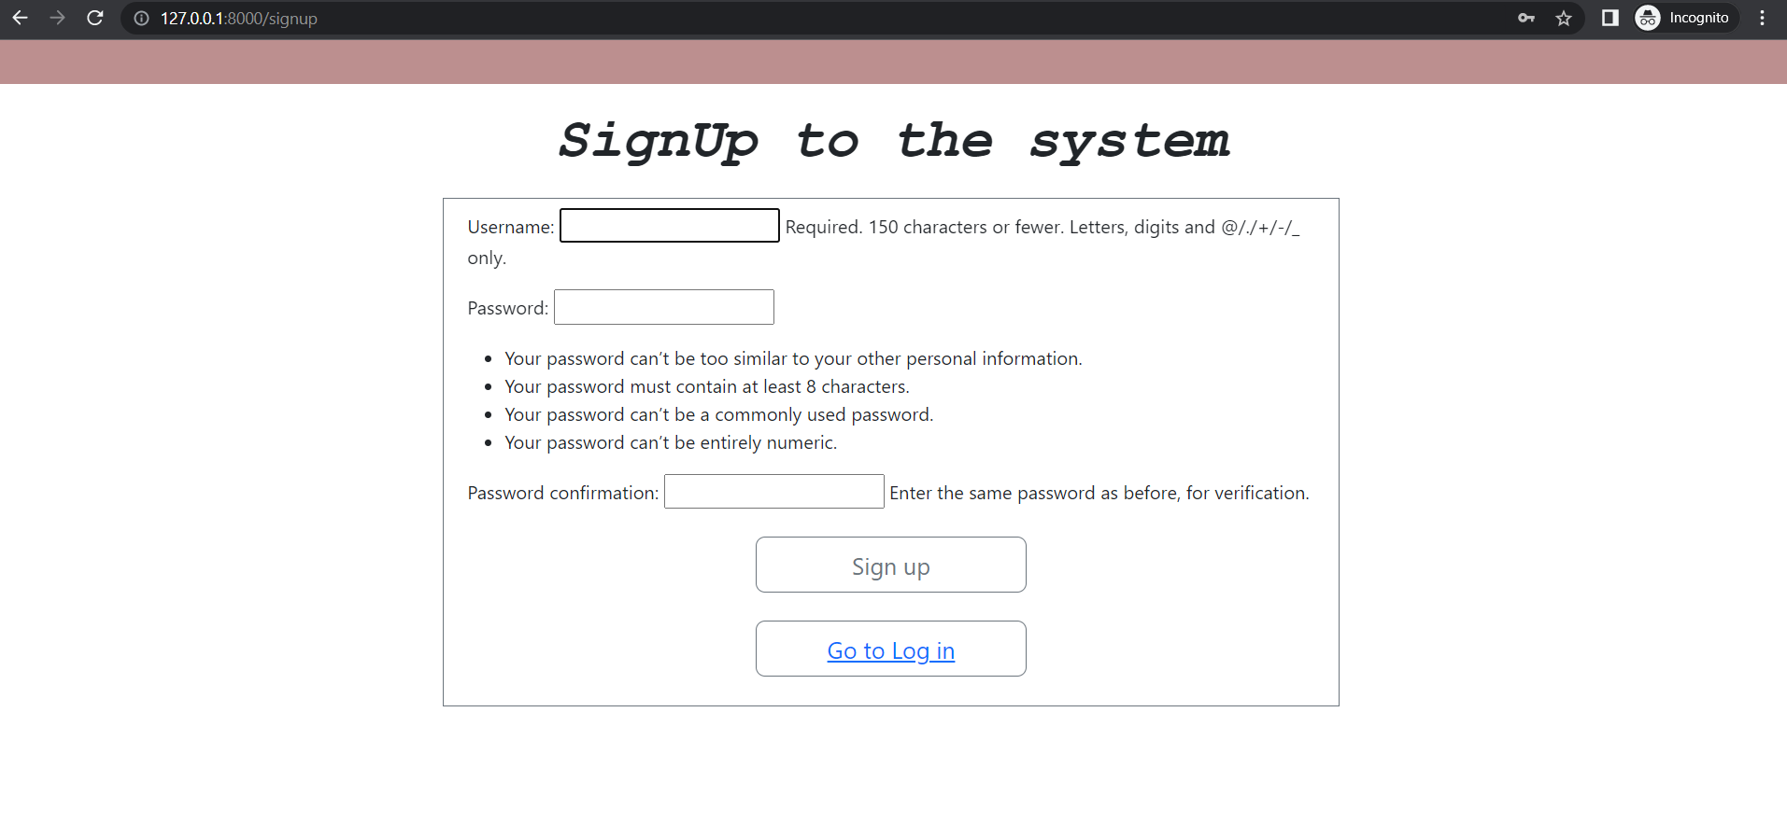

If a user is not registered then, they can register themselves with the sign up button and access the library management system.

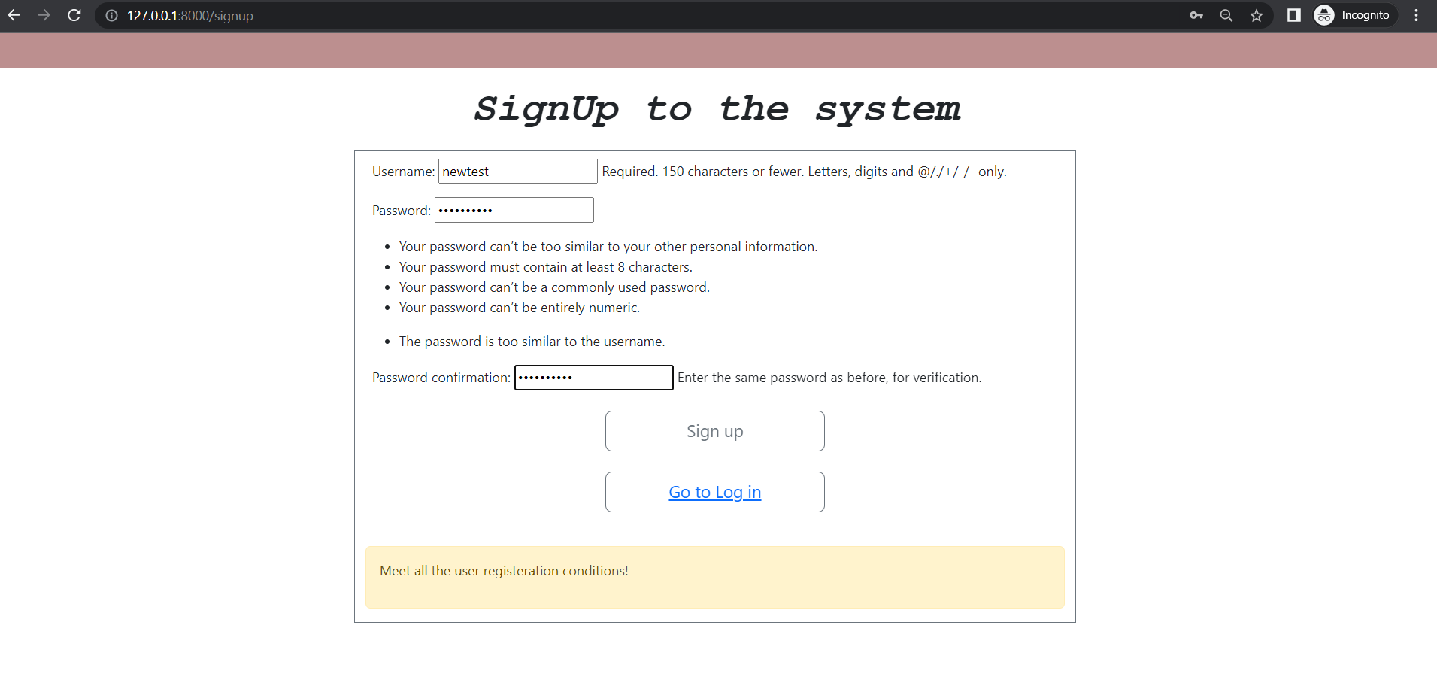

Incase there is an error while registering the error will be shown to the user and they can correct the registration information.

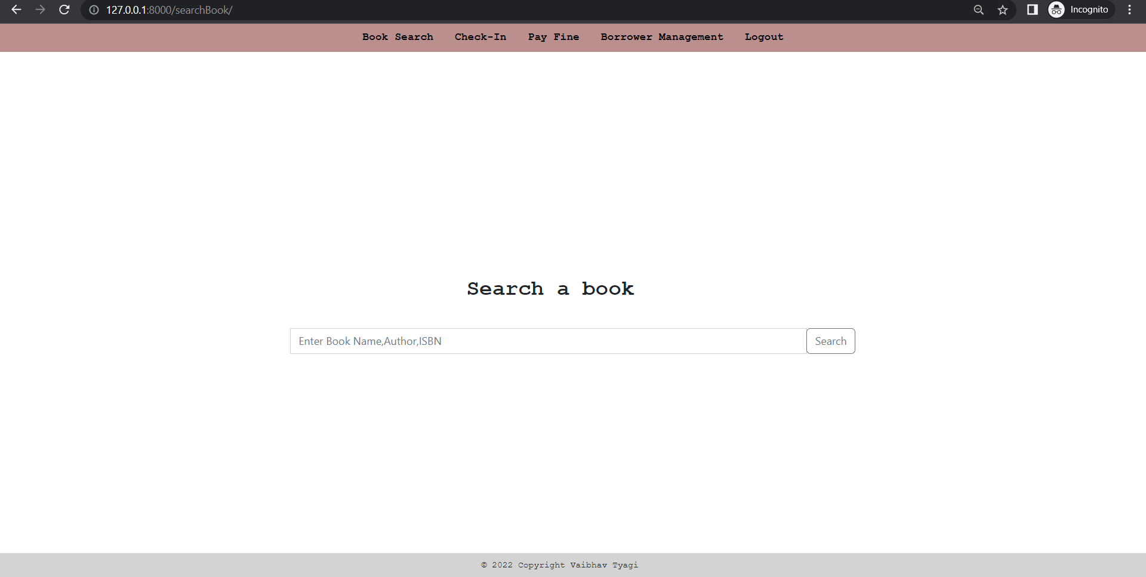

After successful sign up/login the user will be directed to the home page of the book search.

***Book Search:***

User will be directed to book search after successfully authenticating themselves. On this page the user can search any book in the system by entering the Book Name, Book ISBN, or Author Name.

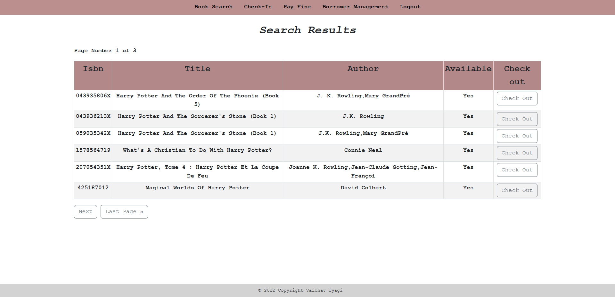

For example, if “Harry Potter” is searched then all the results consisting of Harry Potter in the title will be displayed to the user. Additionally, the user will be able to navigate to other functionalities at all times when logged into the system through the navigation bar at the top.

***Check-Out:***

After searching for the book, the user will be able to check-out a book in the search result by clicking on “Check Out” button respectively for each book.

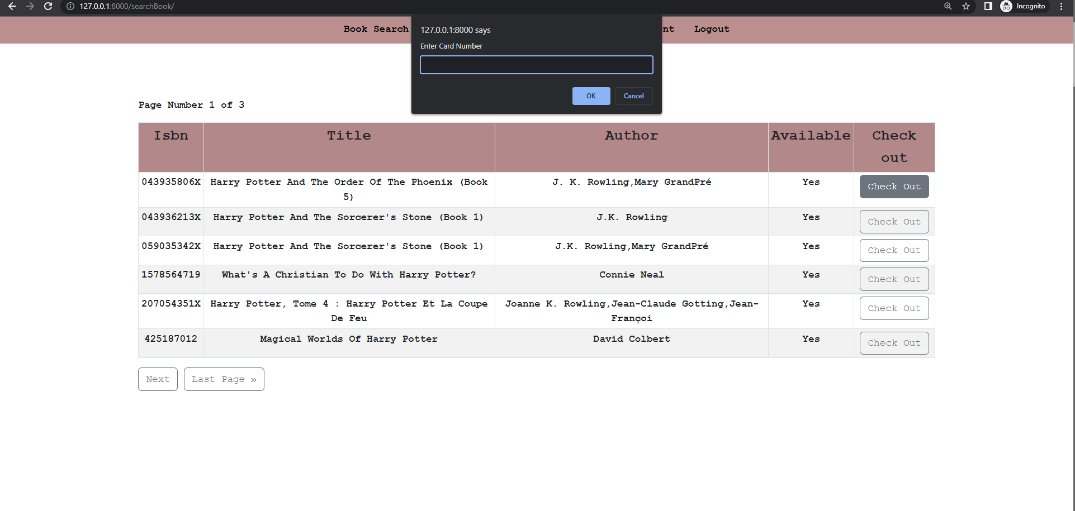

A prompt will be displayed asking for the borrower’s card no to be entered. A book will be successfully checkout if it meets the requirements given in the instructions such as, if the book is available or if the borrower hasn’t borrowed three books already.

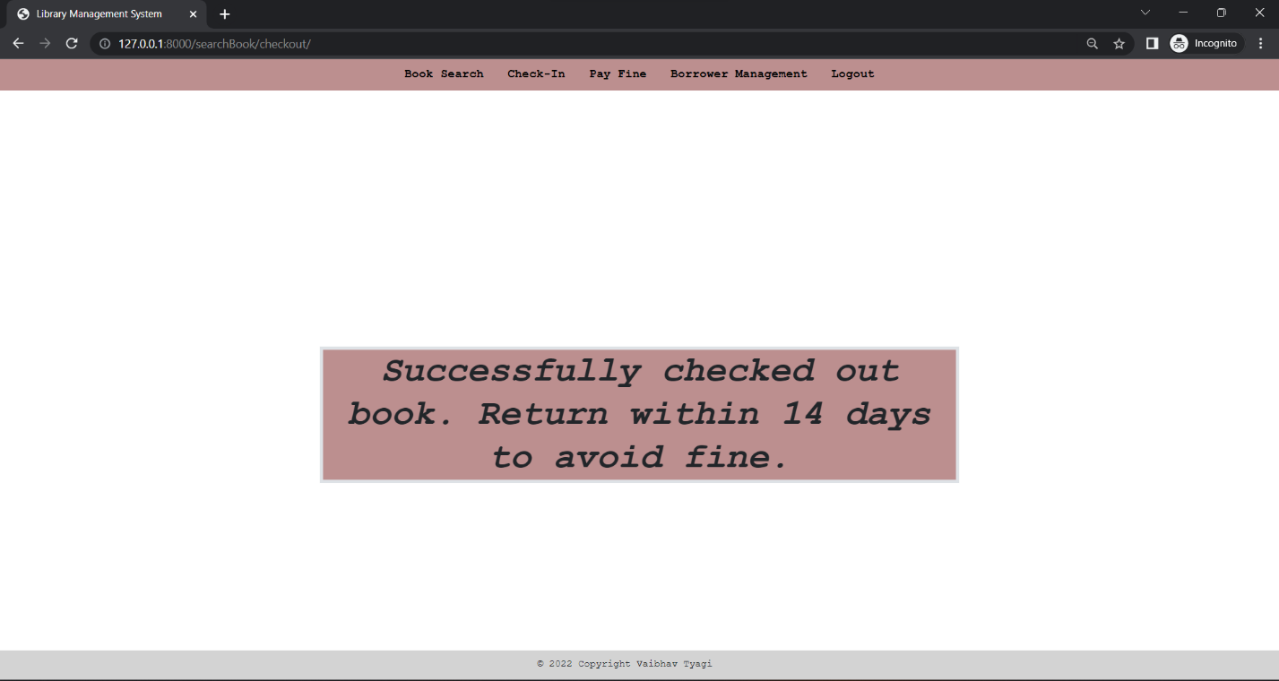

Upon successfully checking out the book, the system will display a success message. If it fails then a failing message.

***Check-In:***

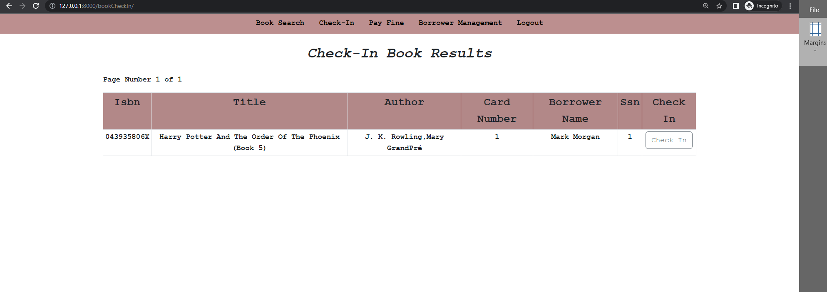

The books can be checked in, by going to the check-in page and searching for the book name, borrower name or borrower card no. If a book/User has a book checked out then the search results will be displayed accordingly, else a no book found message will be displayed.

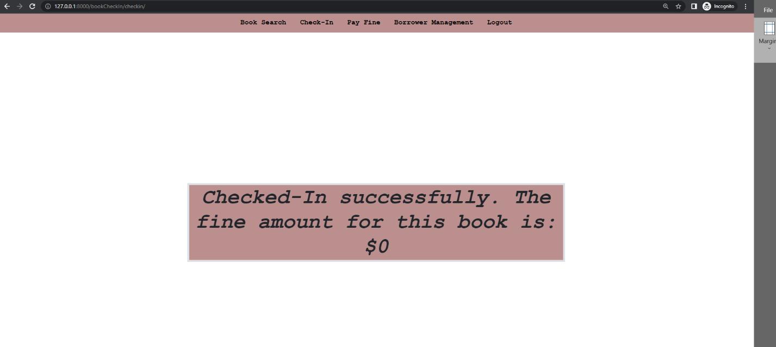

After checking-in a book a success message will be displayed along with the fine amount.

***Pay fines:***

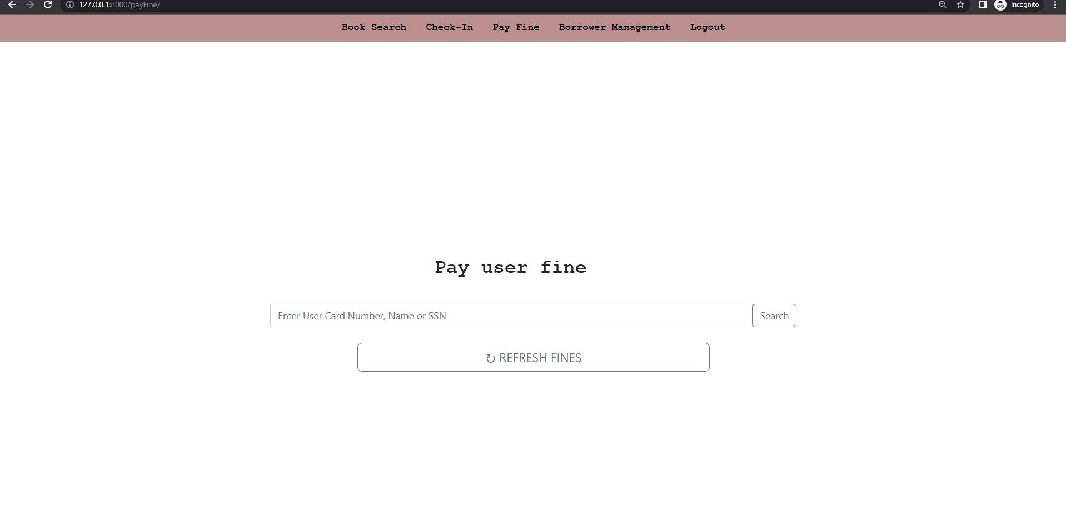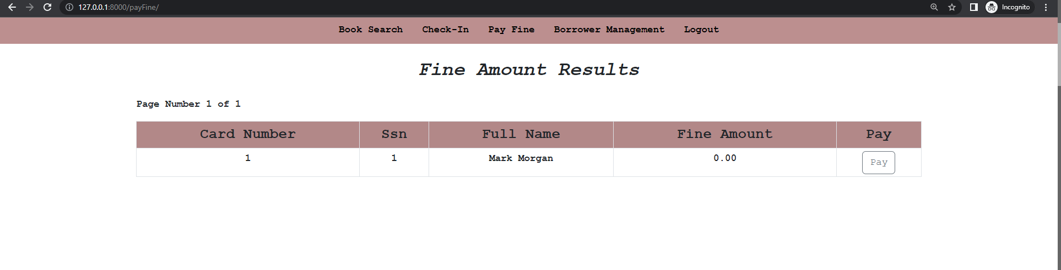

There is a pay fine functionality which can be used by the librarian to refresh the fine amount and mark the fine to paid if it is paid by the borrower.

***Add borrower:***

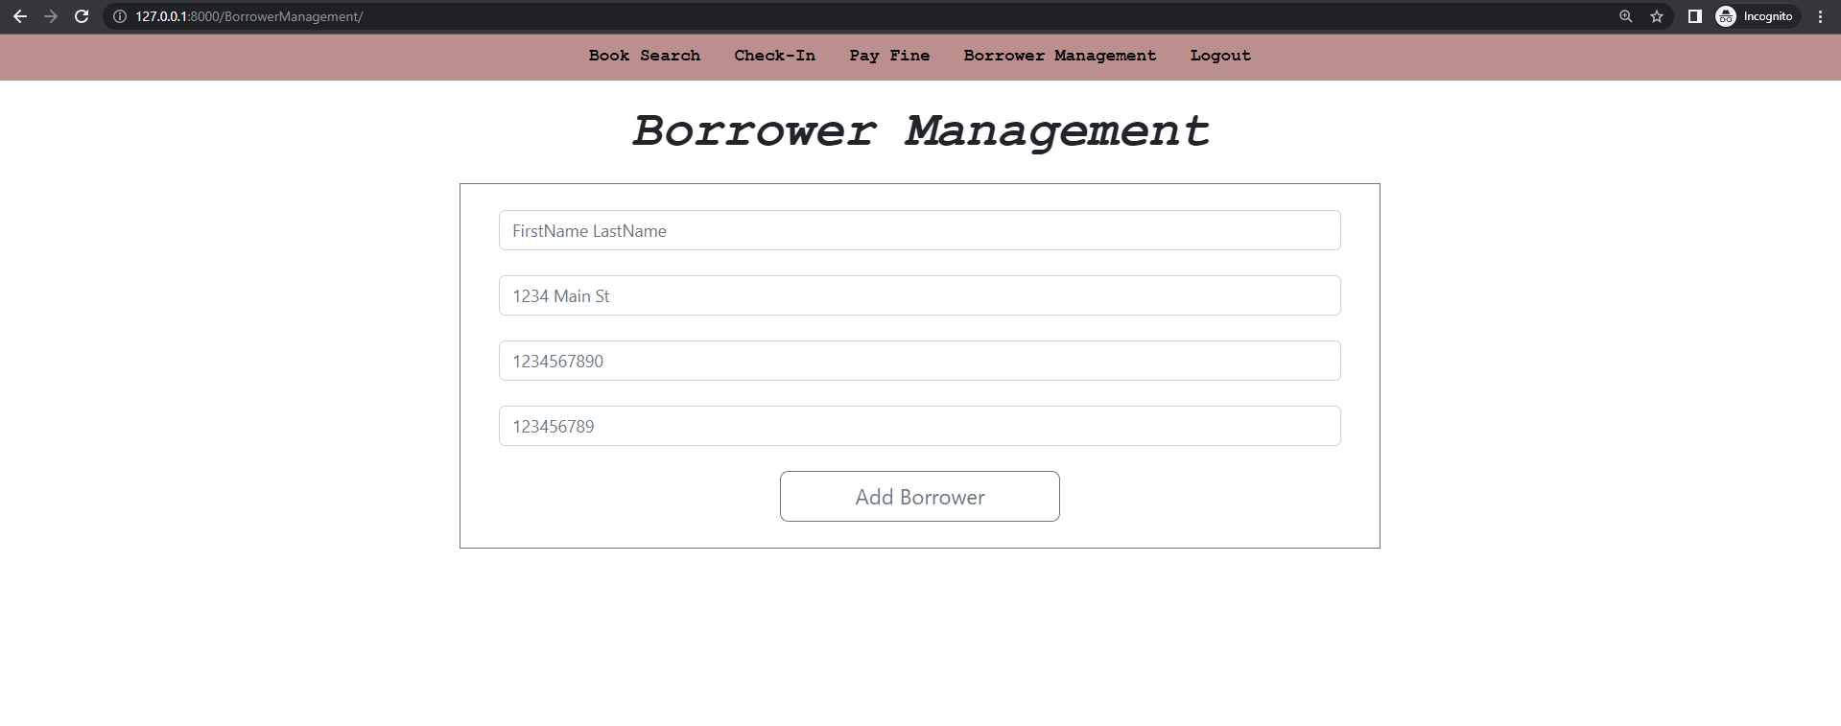

A borrower can be added through this page. The form will ask basic details about the borrower and add it to the database.

Further in the navigation bar, a functionality to **logout** out of the system will be provided to the user at all times. Once logged out of the system the system will take the user back to login page and ask for the credentials again to access the system.

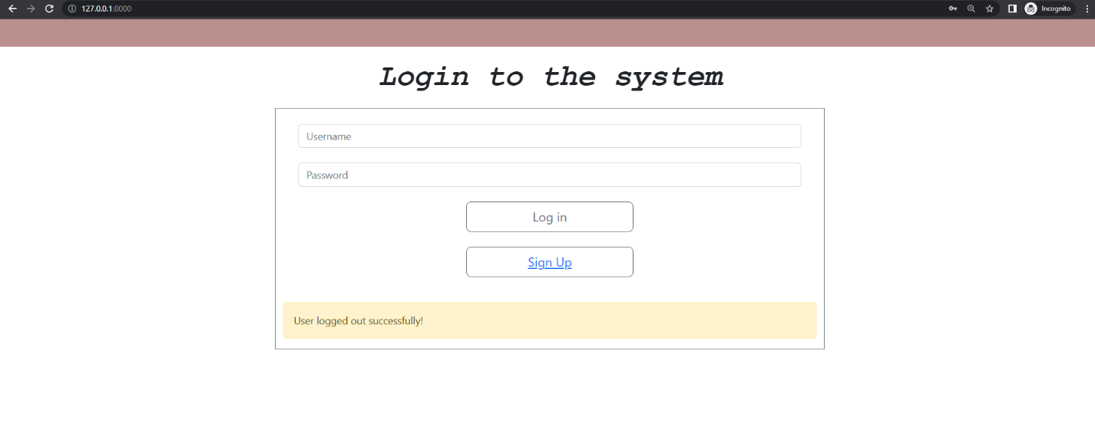

AND Fines.Paid = '0' AND Book_Loans.Date_in IS NOT NULL